LMS Quiz – Questions Types

You may add a variety of different types of questions in the Quiz and Lesson modules. The most commonly used quiz question types are listed below with brief descriptions.

1. Multiple Choice
There are two types of multiple choice questions - single answer and multiple answer.
Multiple choice questions now offer the learner the option to clear all answers, once they have made a selection:
Single-answer questions
These questions allow one and only one answer to be chosen by providing radio buttons next to the answers. You can specify negative or non-negative marks for each answer, usually zero marks for wrong answers, maximum marks for correct answers and partial marks for partially correct answers.
Multiple-answer questions
The teacher can select "multiple answers are allowed" in a Multiple Choice question type. "Multiple answers" questions types in a quiz allow one or more answers to be chosen by providing check boxes next to the answers.
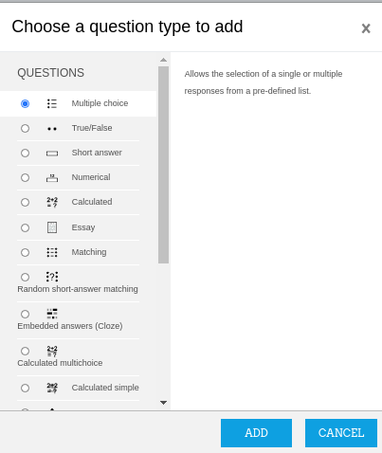

- Select the question type “Multiple Choice” and click on the Add button.
- Select the question category (default question bank category of the course or any sub-category of the question bank)
- Give the question a descriptive name. You'll use the name to track your questions later so "Question 1" isn't a good idea. The name will be used in the question lists on the quiz editing page or in the lesson as a page title. It will not be shown to the students, so you can choose any name that makes sense to you and possibly other teachers.
- Create the question text. If you're using the HTML Editor, you can format the question just like a word processing document.
- If you want to add a picture to the question use the image icon. This will pop up the Insert Image window. You can choose to upload an image into your files area from this window and then click OK.
- Set the 'default question grade' (i.e. the maximum marks for this question).

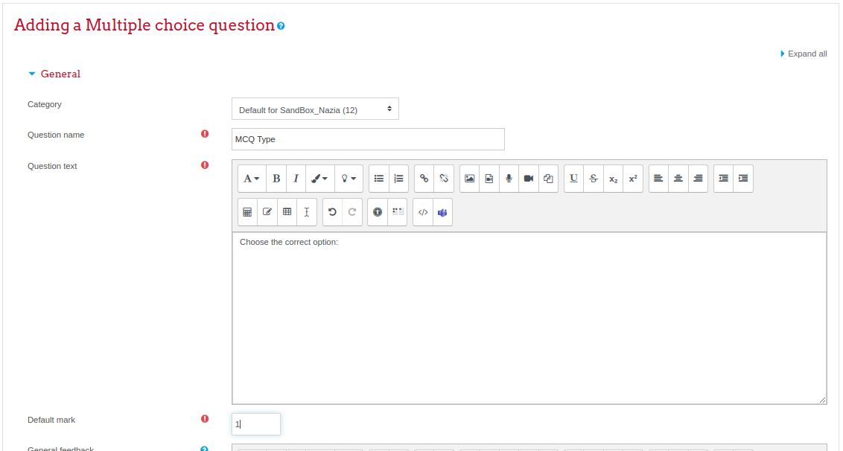

- Choose whether students can only select one answer or multiple answers
- Choose whether to shuffle the answer options
- Choose the number format for answer choices.

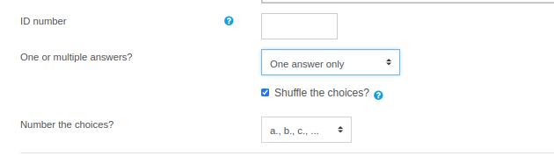
- Write your first answer in the Choice 1 text field. Inserting HTML into this area also makes it possible to add an image or a sound file.
- Select a grade percentage for the answer. This is the percentage of the total points for the question that selecting this response is worth. You can select negative percentages as well as positive percentages. So, selecting a correct response in a multiple answer question may give you 50% of the possible points, while selecting a wrong answer may take away 10%. Note that in a multiple-answer question, the positive grades must add up to at least 100%.
  - Be aware that if you allow multiple answers and have more than a single correct choice, and do not use a negative grade percentage for wrong answers, the students can simply tick all choices and get the full grade.
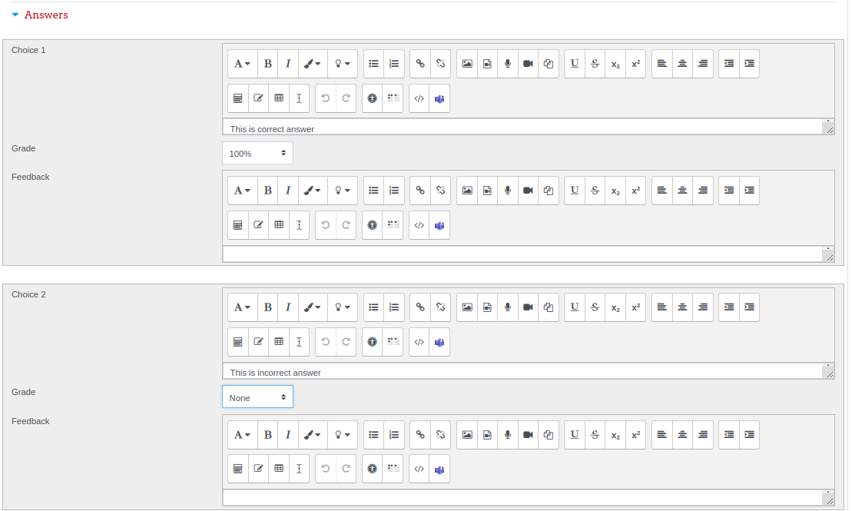
- If you wish, you can add feedback for each response. It may be a bit more work, but it’s good practice to tell the students why each answer is right or wrong using the feedback area. If students know why an answer is right or wrong, they can analyze their own thinking and begin to understand why an answer is correct. Your feedback will only be displayed if you select Show Feedback in the quiz body options.
- Fill in the rest of the response choices in the rest of the form. Any unused areas will be ignored.
- Fill in the overall feedback fields if you wish.
- The 'penalty factor' only applies when the question is used in a quiz using adaptive mode - i.e. where the student is allowed multiple attempts at a question even within the same attempt at the quiz. If the penalty factor is more than 0, then the student will lose that proportion of the maximum grade upon each successive attempt. For example, if the default question grade is 10, and the penalty factor is 0.2, then each successive attempt after the first one will incur a penalty of 0.2 x 10 = 2 points.
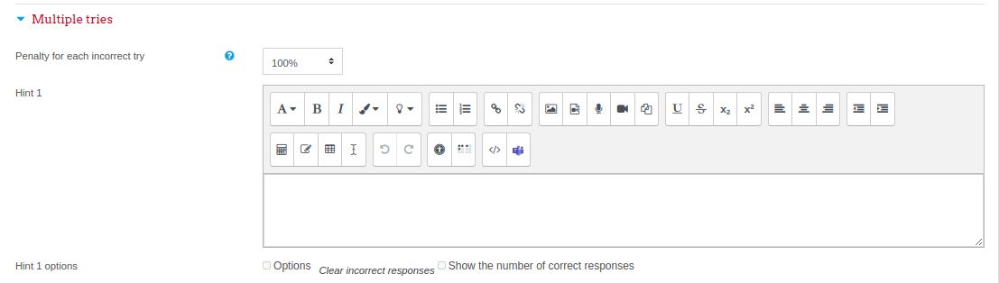

- Select the "Save Changes" button at the bottom of the screen.

- The question is added in the question bank.

2. True/ False:
A student is given only two choices for an answer in this kind of question: True or False. The question content can include an image or html code.

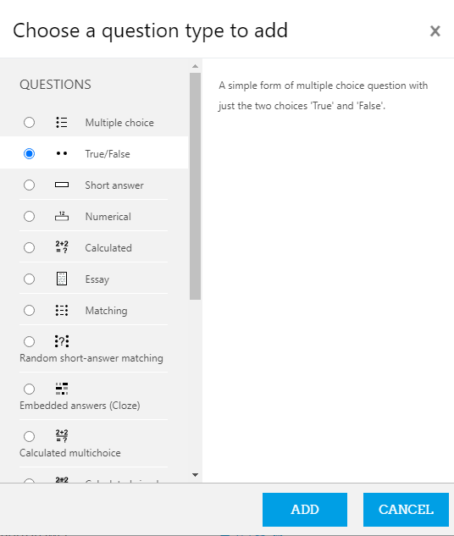

- Select the question category
- Give the question a descriptive name - this allows you to identify it in the question bank.
- Enter a question in the 'question text' field. That can include an image to display if you want to add a picture to the question.
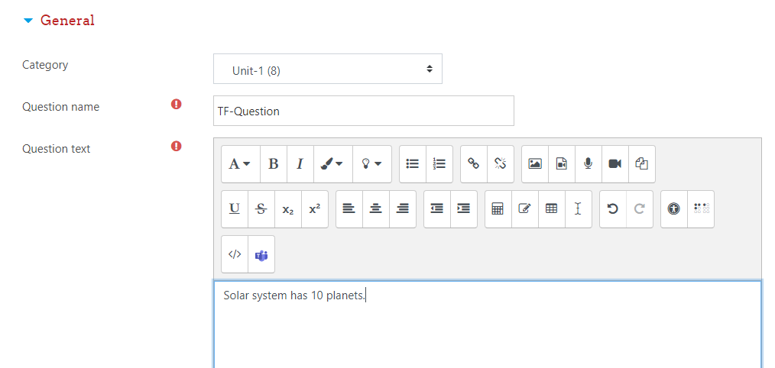
- Set the 'default question grade' (i.e. the maximum number of marks for this question).
- If you wish, add general feedback. This is text that appears to the student after he/she has answered the question.
- Select the correct answer - true or false.
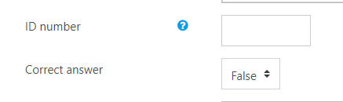
- Finally, provide feedback for each of the answers 'true' and 'false'.
- Click 'Save changes' to add the question to the category.


3. Short Answer/ Fill in the blanks:
In a short answer question, the student types in a word or phrase in response to a question (that may include a image). Answers may or may not be case sensitive. The answer could be a word or a phrase, but it must match one of your acceptable answers exactly. It's a good idea to keep the required answer as short as possible to avoid missing a correct answer that's phrased differently.
Question setup steps are given below:
- Select the question category
- Give your question a descriptive name.
- Create the question text. If you're using the HTML Editor, you can format the question just like a word processing document.
  - Tip: Normally the answer box appears below the question text. However, if you include five or more underscores in the text, the input box will be placed there. For example the question "A water molecule contains two atoms of __________ and one atom of oxygen".
- Select an image to display if you want to add a picture to the question.
- Set the 'default question grade' (i.e. the maximum number of marks for this question).
- If you wish, add general feedback. This is text that appears to the student after he/she has answered the question.
- Choose whether the answers are case-sensitive. Case sensitivity can be tricky where capitalization is important. Will you accept Ban Ki-moon as well as ban ki-moon as an answer?
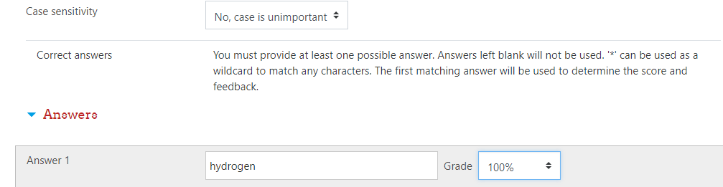
- Next, fill in the answers you will accept.
- Add grade for each answer.
- Click Save Changes to add the question to the category.

4. Numerical:
From the student perspective, a numerical question looks just like a short-answer question. The difference is that numerical answers are allowed to have an accepted error. This allows a fixed range of answers to be evaluated as one answer.
For example, if the answer is 30 with an accepted error of 5, then any number between 25 and 35 will be accepted as correct.
You are able to
- grade independently the number and the unit,
- choose to handle the unit response either as
  - a text input element or as
  - a multichoice radio element,
- just grade the number with the option to write the unit close to the input element,
- put the unit either
  - at right of the number as the most common occurrence
  - or at left as in $ 100,00.
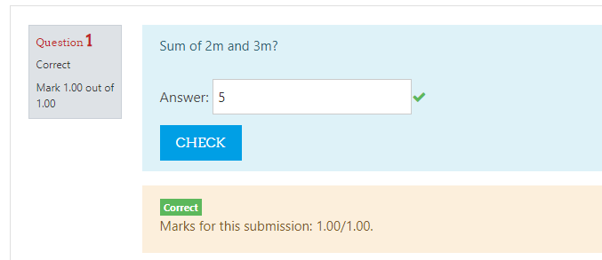

Text answers are no longer allowed.

- Select the question category
- Give the question a descriptive name - this allows you to identify it in the question bank.
- Enter a question in the 'question text' field. This can include an equation. Alternatively, select an image to display if you want to add a picture to the question.
- Select an image to display if you want to add a picture to the question. For the student, it appears immediately after the question text and before the choices.
- Set the 'default question grade' (i.e. the maximum number of marks for this question).
- Add general feedback. This is text that appears to the student after he/she has answered the question.
- Now enter the first accepted answer(s). Note: Floating point numbers, e.g. 23.4, may also be written as 23,4 or 2.34E+1.
- Enter an accepted error for this answer. This is the range above or below the answer that Moodle will accept as a match. For example, if the correct answer is 5, but you will accept 4.8 or 6.2 as answers, your accepted error is 0.2.
- Enter a grade for this answer.
- Enter feedback for the accepted answer. This is the text that the student will see if they enter a number within the accepted error of the answer.
- Repeat for each of the answers you want to accept. You can provide feedback for all wrong answers by using a wildcard, i.e. the asterisk character (*), as an answer with grade 'None'.
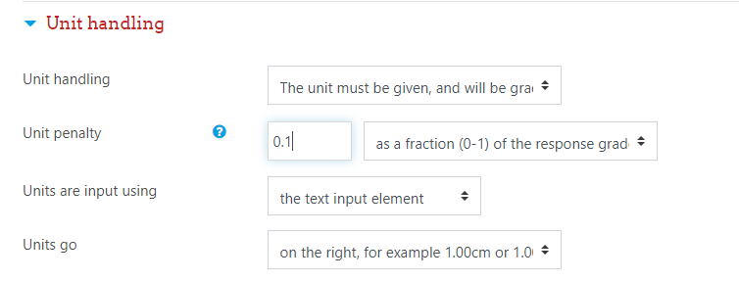
- Units can also be specified. For example, if you enter a unit of 'cm' here, and the accepted answer is 15, then the answers '15cm' and '15' are both accepted as correct. You can also specify a multiplier. So, if your main answer was 5500 with unit W, you can also add the unit kW with a multiplier of 0.001. This means that the answers '5500', '5500W' or '5.5kW' would all be marked correct. Note that the accepted error is also multiplied, so an allowed error of 100W would become an error of 0.1kW.
- Click 'Save changes' to add the question to the category.

5. Calculated:

Calculated questions offer a way to create individual numerical questions by the use of wildcards (i.e you can use common variables names as x , y enclosed in curly braces to create the wildcards {x} and {y}) that are substituted with random values when the quiz is taken.
For example, if you want to create a large number of "Calculate the area of a rectangle" problems to drill your students, you could create a question with two wildcards (i.e. {base}, {height} created from the common base, height variable names) and put in the "Correct Answer Formula=" input field {base} * {height} ( * being the multiplication sign ).
Correct Answer Formula= {base}*{height}
When a student takes the test, Moodle will randomly select values for {base} and {height} and grade the response using the result of the Correct Answer Formula.

Example Question: The device ‘X’ requires 4 volts and 1.5 mA and device ‘Y’ operates at 2 volts and 1 mA. Using KCL and KVL, design the circuit i.e. specify the values of R₁ and R₂.
Choose V_{S} = {Vs}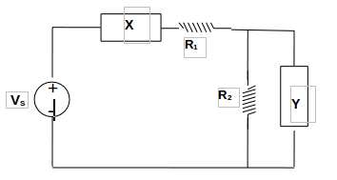

- Open the question bank and navigate to the sub-category where you want to create the question.
- Write name of the question (This name will not display to the students).
- Add question text. The variable for which you want to randomize its value for all students, should be written in curly brackets i.e. {Vs} in the question text.
- An image can be directly pasted in the editor.

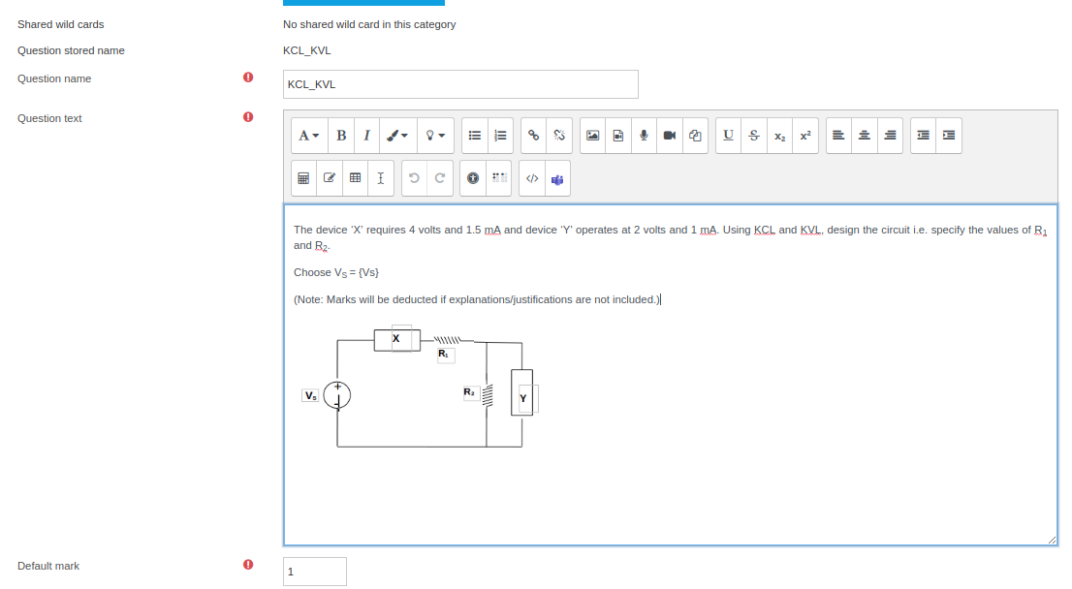
- Add the correct answer formula by using the variable and select “Grade” to 100%.
- Absolute or relative tolerance can be provided (if necessary).

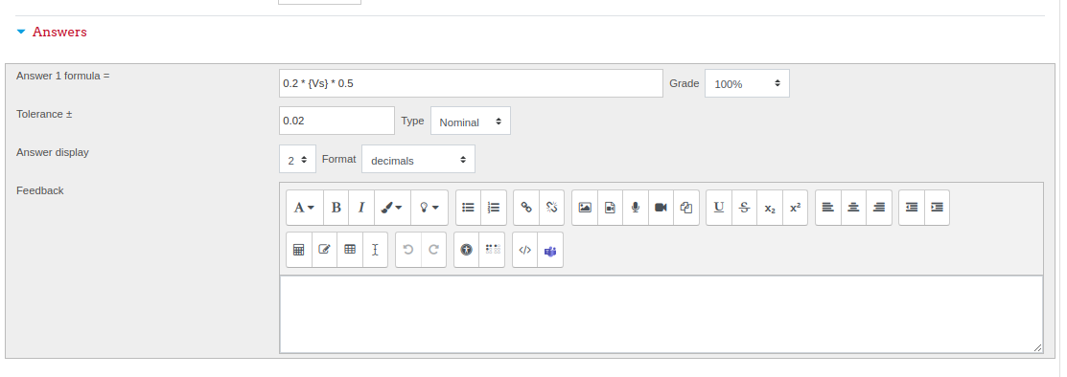

7. Click on “Save changes” button.

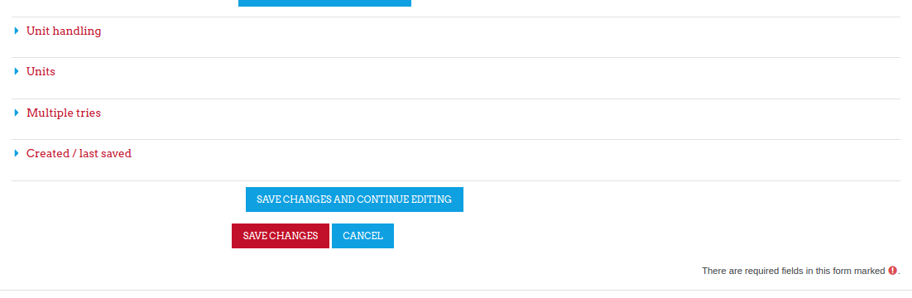
- Upon saving the changes, system will ask you to define the variable you have added into the question and its answer. (Variables are termed as “Wild Card” in LMS). If you do not want to share this variable among different qustions of your quiz, keep the default option selected i.e. Will use the same existing private dataset as before” and Do not synchronise. Click on “Next page”.

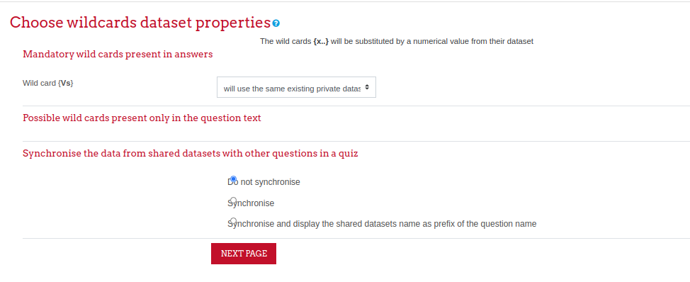

- Choose the range of variable by setting the minimum and maximum values. Adding decimal places will result in generation of more randomized set of variable values. Choose a distribution method for variable values.

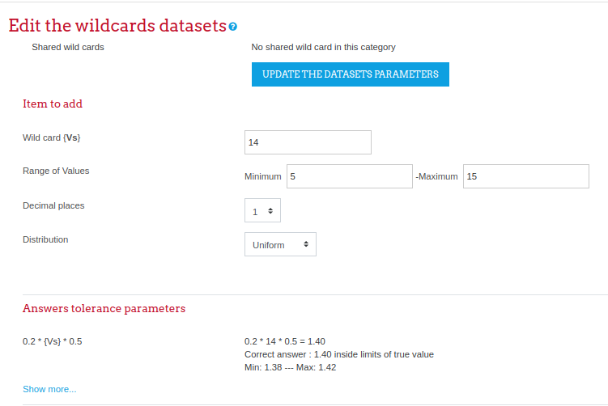

- Select the number of random sets you want to add for the variable(s) and click on “ADD” button. e.g. choosing 20 will generate 20 sets of this variable which will be distributed among the stduents during quiz.
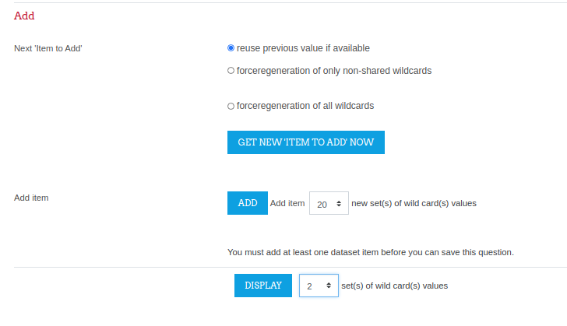

- You can choose any number to display the generated set of questions.
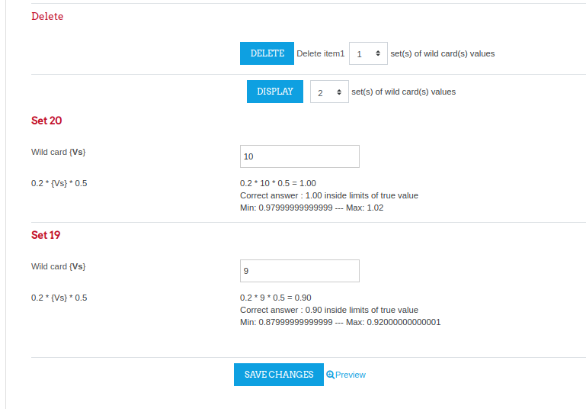

- Verify the answers from the displayed sets of questions and save the changes.
- Question is added into selected category of your question bank. Using preview icon (magnifying glass icon) you can preview how question will appear to the students.
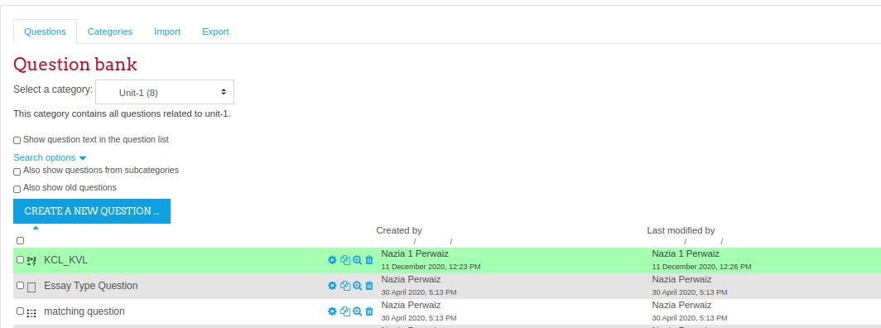
- Variable value is selected from the range you have defined while creating the question.

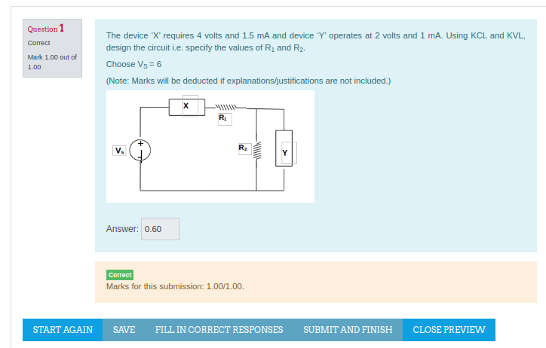

- Another preview of the same question will fetch a different value of the variable Vs.

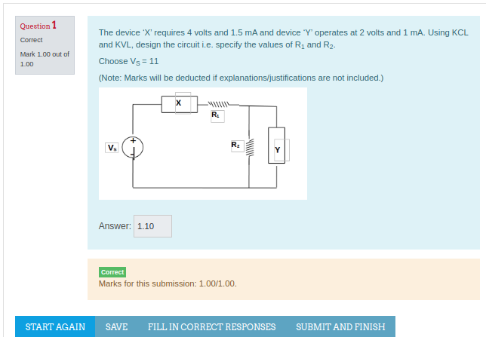

Essay:
The essay question type provides the option of answering by uploading one or more files and/or entering text online. (For longer essays, text or file uploads, you may wish to consider using the “Assignment activity” rather than this question type.)
Essay questions are created in the same way as other quiz question types. The difference is that essay questions have to be marked manually, and the student will not get a final grade until the teacher has marked their essay.
- Give the question a descriptive name - this allows you to identify it in the Question bank.
- Enter the question in the 'Question text' field. This will be the title of and information about the essay you wish them to write.
- Set the 'default mark' and any 'General Feedback' if required. This is text that appears to the student once you have graded their essay.
- 'Require text' allows you to decide whether or not students must add text into the text editor when they do the question. If you only want them to upload a word-processed file as an essay, then you can set this to 'Text input is optional'. (Note that this setting does not force the student to type text into the text editor; they can still leave it blank and continue to another question.)
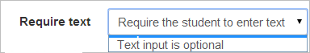
- Response format' allows you to choose what is available for the students when typing their essays. It is possible for a teacher to create a template to scaffold the student's answer in order to give them extra support. The template is then reproduced in the text editor when the student starts to answer the question
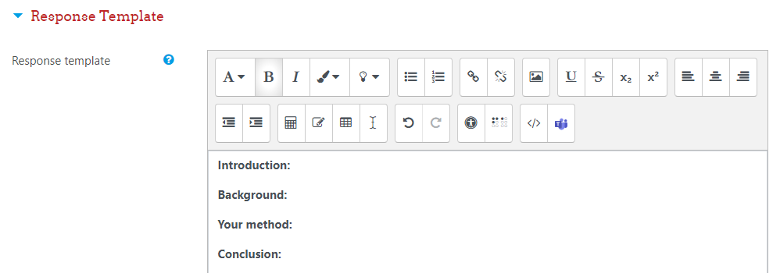
- Student view of the question is shown in the next image:
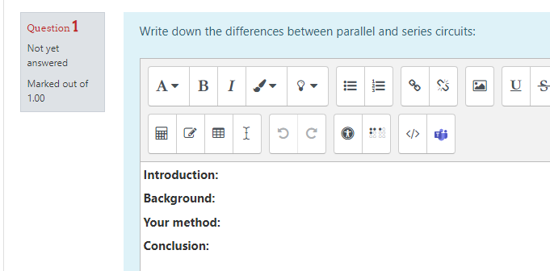

- The essay question will not be assigned a grade until it has been reviewed by a teacher and manually graded. Until that happens, the student's grade will be 0.
- When manually grading an essay question, the grader is able to enter a custom comment in response to the essay and assign a score for the essay.
- If necessary the teacher can also upload a file such as an image (or even record audio/video) in the essay grading box.
- Save changes

Embedded Answers/ Cloze:
Embedded answers (Cloze) questions consist of a passage of text (in Moodle format) that has various answers embedded within it, including multiple choice, short answers and numerical answers. e.g question:
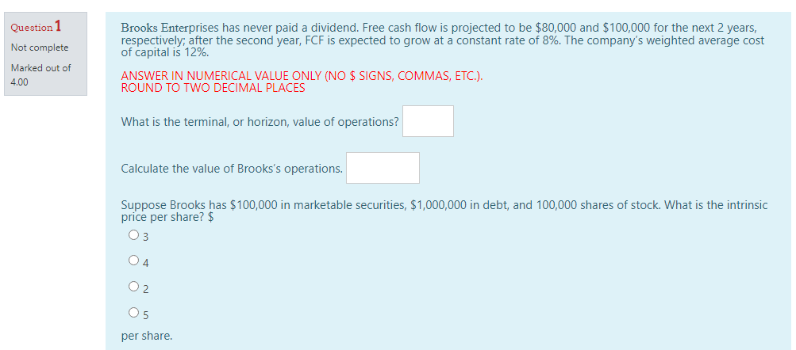

- Select the question category
- Give the question a descriptive name - this allows you to identify it in the question bank.
- Enter the passage of text into the 'question text' field.
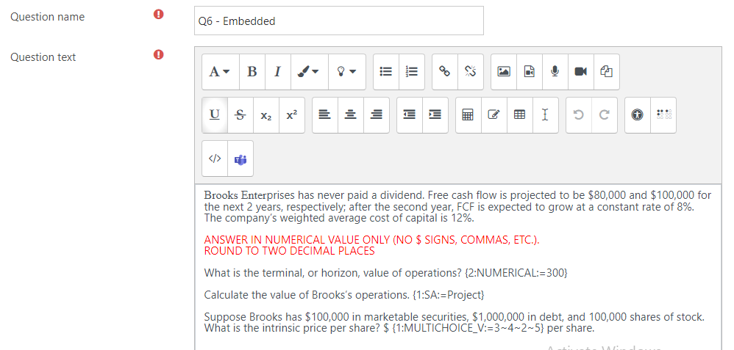
Questions consist of a passage of text (in Moodle format) that has various sub-questions embedded within it, including
- short answers (SHORTANSWER or SA or MW), case is unimportant,
- short answers (SHORTANSWER_C or SAC or MWC), case must match,
- numerical answers (NUMERICAL or NM),
- multiple choice (MULTICHOICE or MC), represented as a dropdown menu in-line in the text,
- multiple choice (MULTICHOICE_V or MCV), represented as a vertical column of radio buttons, or
- multiple choice (MULTICHOICE_H or MCH), represented as a horizontal row of radio-buttons,
- multiple choice (MULTIRESPONSE or MR), represented as a vertical row of checkboxes
- multiple choice (MULTIRESPONSE_H or MRH), represented as a horizontal row of checkboxes
- Select an image to display if you want to add a picture to the question. For the student, it appears immediately above the question text.
- Set the 'default question grade' (i.e. the maximum number of marks for this question).
- If you wish, add general feedback. This is text that appears to the student after he/she has answered the question.
- The editor has been modified and allows you to test if your syntax is good. The different questions elements decoded will be displayed and syntax errors pinpoint. However, it cannot check if the question decoded is two questions in one because of an error syntax (for example ~}, =~, etc.).
- Click Save changes to add the question to the category.

Description:
A Description question page simply shows some text (and possibly graphics) without requiring an answer. It is more of a label than a question type.
Note that these questions are not really questions so they are ignored when adding random questions from a category.
TIP: When shuffling questions is turned off, this type of page can provide information to be used by a following group of questions.

___________________________

